Sorry I cant find a way of making a screen cast of two monitors at the same time so I had to just take screen dumps

Running 6.1.50504 on my dual screen desktop wit h Royal-TS running full screen on the second monitor
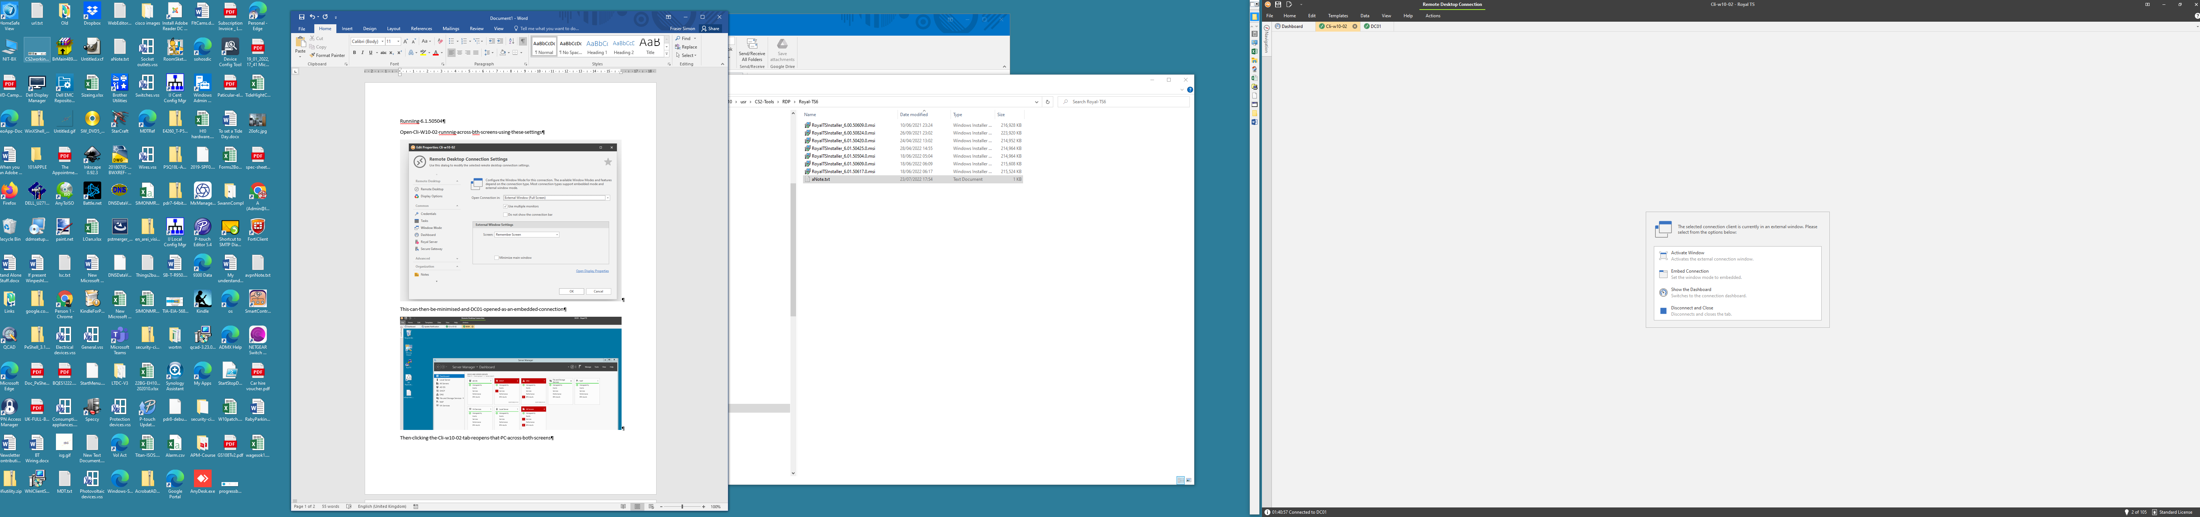
I can use RTS to open a connection to the PC Cli-W10-02 running across both screens using these settings
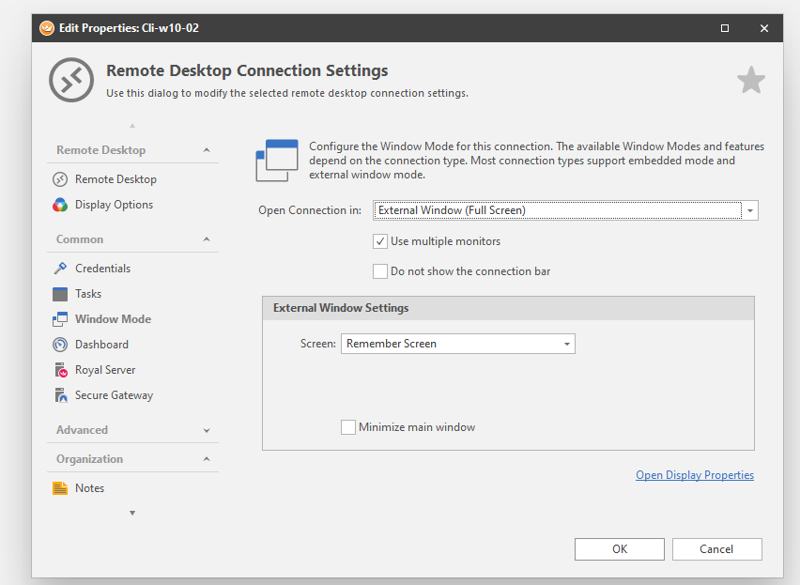
This can then be minimised and DC01 can be opened as an embedded connection
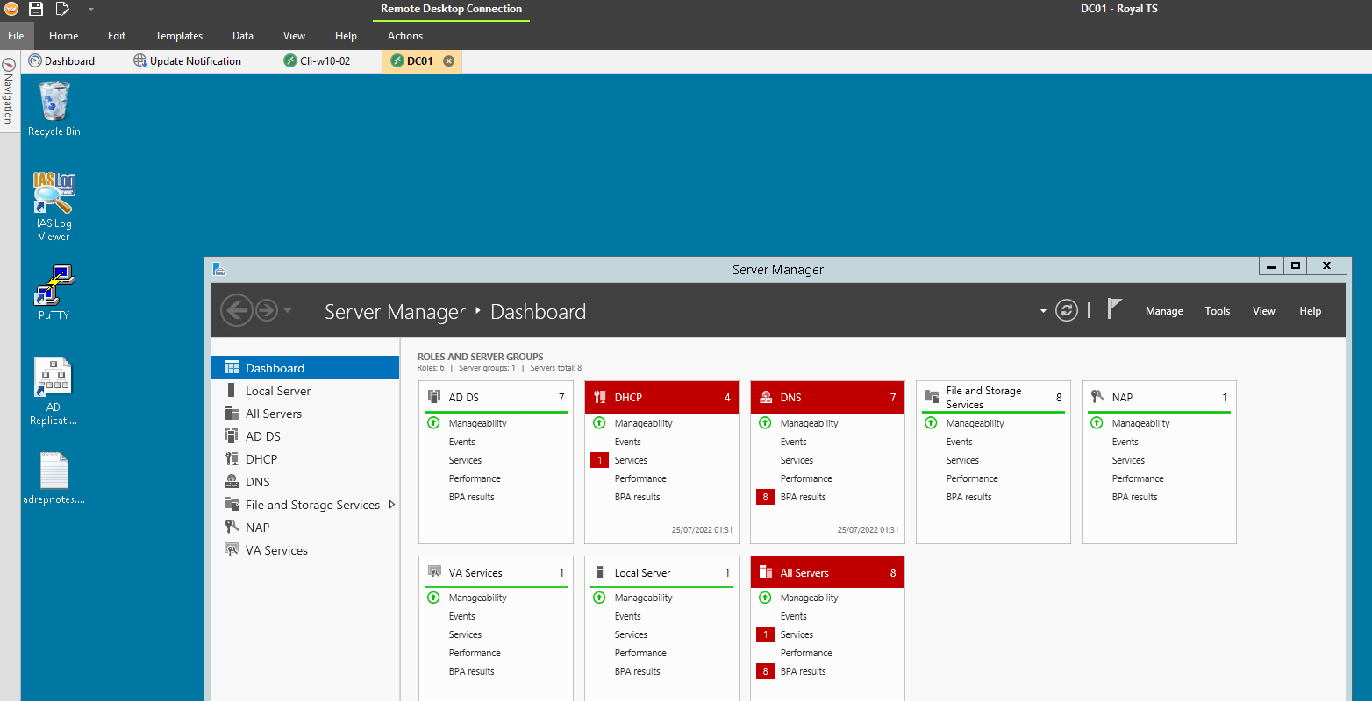
Then clicking the Cli-w10-02 tab reopens that PC across both screens
Minimising Cli-W10-02 causes the original host PC desktop to appear and running Royal-TS. DC1 can be opened by clicking on its tab. This restores the original embedded connection to DC01 . I can then click the Cli-W10-02 tab and it is restored full screen across both monitors..

Once upgraded to 6.01.50722
The dual screen connection to W-Cli-02 opens OK and can be minimised as before. However clicking on the tab for Cli-W10-02 does not restore it to both monitors. It does nothing. Double clicking it opens an embedded connection to Cli-W10-02. Single clicking DC01 opens it embedded and then single clicking Cl-w10-02 opens it embedded.

