Using direct Internet connection (not behind Socks 5 Proxy):

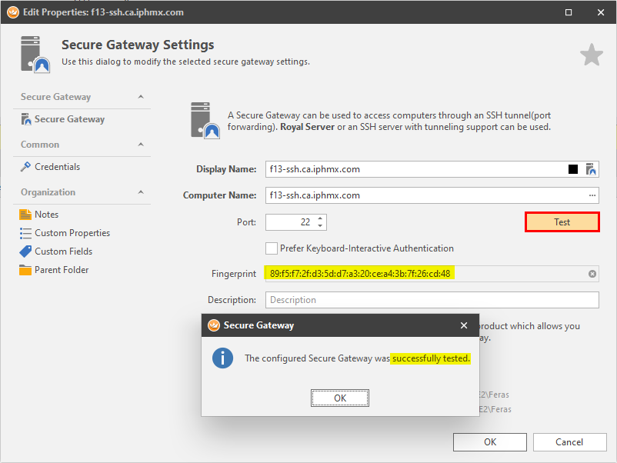

Using Corp Internet connection (Behind Socks 5 Proxy):

